**Tampilan Login**

**Tampilan Register**

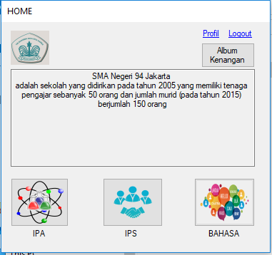

**Tampilan Halaman Awal**

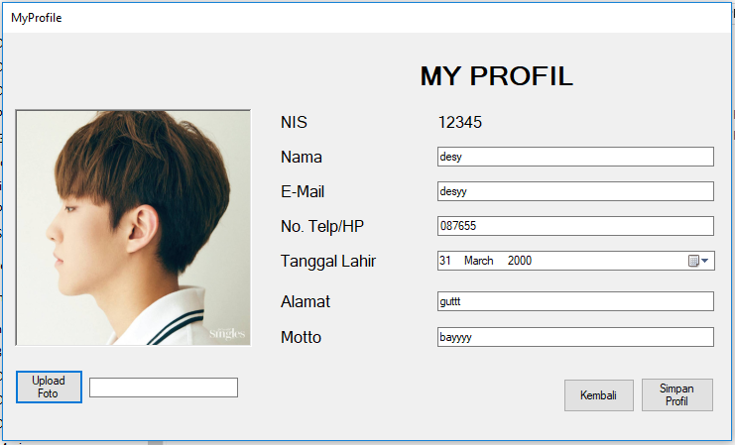

**Tampilan Profil Pengguna**

**Tampilan Foto dalam Album Kenangan**

**Tampilan Video dalam Album Kenangan**

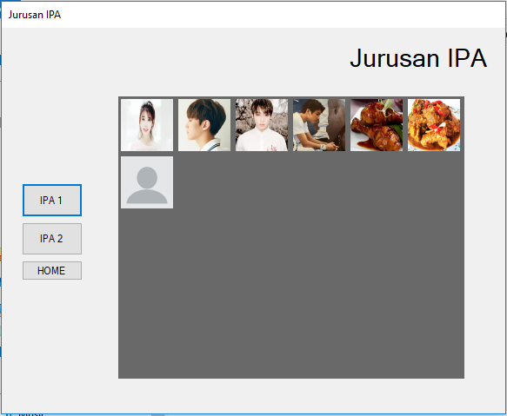

**Tampilan Semua Siswa IPA 1**

**Tampilan Detail Profil Siswa**